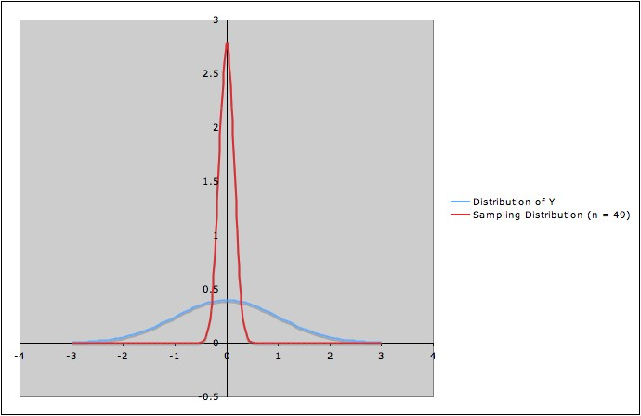

* Which column of the chart on the previous page corresponds to the blue distribution?
* Which column of the chart on the previous page corresponds to the red distribution?
* How does the picture reflect the compare and contrast above?
* How does the picture relate to what we got in the sampling distribution demo?

The following chart summarizes which model assumptions are necessary to prove which part of the theorem:

|  |  |  |  |
| --- | --- | --- | --- |
|  | Conclusions ***about Sampling Distribution*** (Distribution of ) | | |
|  | 1: Normal | 2: Mean µ | 3: Standard deviation |
| Assumption 1 (Y normal) | √ |  |  |
| Assumption 2 (simple random samples – i.e., independence) | √ |  | √ |

Note that:

1. The conclusion that the sampling distribution  has the same mean as Y does *not* involve either of the model assumptions.
2. The independence assumption is needed for *both* of the other two conclusions (that the sampling distribution is normal and that the sampling distribution has standard deviation ).

Forming the confidence interval proceeds by the following steps:

1. First, we specify some high degree of probability; this called the *confidence level. (*We’ll use 0.95 to illustrate; so we’ll say “95% confidence level.”)
2. The first two conclusions of the theorem (that the sampling distribution of  is normal with mean *µ*) imply that there is number *a* so that

(*)    The probability that  lies between *µ* - a and *µ* + a is 0.95:

P(*µ* - a <  < *µ* + a)  0.95

[Draw a picture of the sampling distribution to help see why!]

***Caution***: It’s important to keep in mind what is a random variable and what is a constant:

* Is *µ* a constant or a random variable? _______________
* Is *a* a constant or a random variable? ________________
* Is  a constant or a random variable? ________________

Here, the random variable is in the middle of the interval, which is what makes the most sense in a probability statement. All is good!

*Robustness again:*

In practice we can’t find *a* exactly for this procedure, since we don’t know σ.

* But using the sample standard deviation *s* to approximate σ will give a good approximation.
* And, once we actually have a sample, we will know the value of n, so we can use a t-distribution to find a more precise value for *a* for that sample size.
* Many procedures are “exact” (that is, don’t require an approximation), but the additional complications they involve make this procedure better for explaining the basic idea.

1. A little algebraic manipulation (which can be stated in words as, “If the estimate is within *a* units of the mean *µ,* then *µ* is within *a* units of the estimate”) allows us to restate (*) as

(**)   The probability that *µ* lies between  - a and  + a

is approximately 0.95:

P( - a < *µ <*  + a) is approximately 0.95

This is looking a strange. Our ONE random variable now appears TWICE in the statement. This is strange for a probability statement, but is still a valid probability statement, because it is exactly the same relationship between  , a, and *µ*  as before.

On the following page is a picture of the result of taking 100 different simple random samples from a population and using each to form a confidence interval for the mean. To create this, we had to know entire population (so that we could repeatedly sample from it, so we knew the mean *µ.* Notice that the endpoints of the intervals differ, just as the notation says they will.

Also notice that not all 100 of them include the actual population mean. That is what we expect – we asked for the probability to be 0.95 that an individual confidence interval would include the mean.

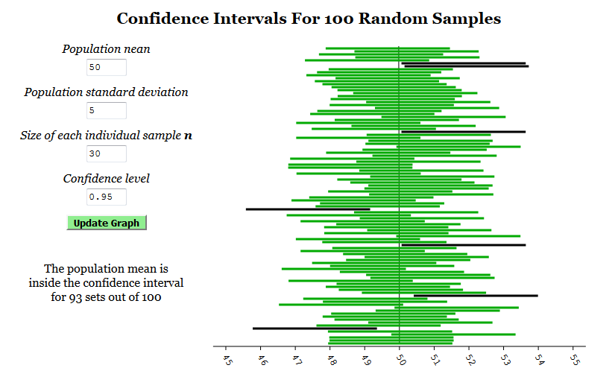

<http://visualize.tlok.org/elem-stat/mean_confidence_intervals.php>

(**)   The probability that *µ* lies between  - a and  + a

is approximately 0.95:

P( - a < *µ <*  + a) is approximately 0.95

***Reinforcement***: It’s again important to be clear about what is variable here. That hasn't changed: it’s still the *sample* that is varying, *not* *µ or a.*  So the probability still refers to , *not* to *µ.*

*Thinking that the probability in (**) refers to µ is a* **common mistake** *in interpreting confidence intervals.*

While (**) is a correct statement, as soon as you do the obvious next step of putting a sample mean in for  so you have numbers at the end of your confidence interval, this is not a probability statement any longer!!!

* We’re now faced with two possibilities (assuming the model assumptions are indeed all true):

1) The sample we have taken is one of the approximately 95% for which the interval from - a to + a *does* contain *µ.* ☺

2) Our sample is one of the approximately 5% for which the interval from  - a to  + a does *not* contain *µ.* ☹

* Unfortunately, *we can't know which of these two possibilities is true for the sample we have.* ☹
* So we are left with some (more) *uncertainty.*
* Since this is the best we can do, we calculate the values of  - a and  + a *for the sample we have*, and call the resulting interval a *95% confidence interval for* *µ.*
  + We do not say that ~~there is 95% probability that~~ *~~µ~~* ~~is between 48 and 51.5~~
  + We ***can*** say that *we have obtained the confidence interval by using a procedure that, for approximately 95% of all simple random samples from Y, of the given size n, produces an interval containing the parameter µ that we are estimating.*
  + Unfortunately, we ***can't*** ***know*** whether or not the sample we’ve used is one of the approximately 95% of "nice" samples that yield a confidence interval containing the true mean *µ*, or whether the sample we have is one of the approximately 5% of "bad" samples that yield a confidence interval that does not contain the true mean *µ.*
  + We can just say that we have used a procedure that "works" about 95% of the time.
  + In other words, “confidence” is in *the degree of reliability of the* *method\**, ***not*** of the result.

*“The method” here refers to the entire *process:*

*Choose sample* 🡪

*Record values of Y for sample* 🡪

*Calculate confidence interval.*

I hope this convinces you that:

* A result based on a single sample could be wrong, even if the analysis is carefully carried out!
* Consistent results from careful analyses of several independently collected samples would be more convincing.
* I.e., **replication of studies, using independent samples, is important!** (*More on this later.)*

*In general:* We can follow a similar procedure for many other situations to obtain confidence intervals for parameters.

* Each type of confidence interval procedure has its own model assumptions.
  + *If the model assumptions are not true, we can’t be sure that the procedure does what is claimed*.
  + However, some procedures are *robust* to some degree to some departures from models assumptions -- i.e., the procedure works pretty closely to what is intended if the model assumption is not too far from true.
  + As with hypothesis tests, robustness depends on the particular procedure; there are no "one size fits all" rules.
* ***No matter what the procedure is, replication is still important!***

**Variations and trade-offs:**

* We can decide on the "level of confidence" we want;
  + E.g., we can choose 90%, 99%, etc. rather than 95%.
  + Just which level of confidence is appropriate depends on the circumstances. (More later)
* The *confidence level* is *the proportion (expressed as a percentage) of samples for which the procedure results in an interval containing the true parameter.* (Or approximate proportion, if the procedure is not exact.)
* However, *a higher level of confidence will produce a wider confidence interval*.
  + i.e., less certainty in our estimate.
  + So *there is a trade-off between level of confidence and degree of certainty*. (No free lunch!)
* Sometimes the best we can do is a procedure that only gives *approximate* confidence intervals.
  + i.e., the sampling distribution can be described only approximately.
  + i.e., there is one more source of uncertainty.
  + This is the case for the large-sample z-procedure.
* *Note*: If the sampling distribution is not symmetric, we can't expect the confidence interval to be symmetric around the estimate.
  + In this case, there might be more than one reasonable procedure for calculating the endpoints of the confidence interval.
  + This is typically the case for variances, odds ratios, and relative risks, which usually have sampling distributions that are skewed distributions (e.g., F or chi-squared).

Picture:

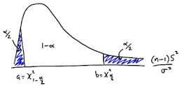

* There are variations such as "upper confidence limits" or "lower confidence limits" where we’re only interested in estimating how large or how small the estimate might be.

***Confidence Interval Quiz:*** *Each statement is an attempt to say what the following statement means:*

*“The interval from 0.5 to 1.2 is a 95% confidence interval for the mean μ of the random variable Y.”*

*Classify each statement as follows:*

* *Doesn’t get it.*
* *Gets it partly, but misses some details*
* *Gets it!*

1. There’s a 95% probability that *μ* is in the interval from 0.5 to 1.2.
2. For 95% of simple random samples of size n from Y, *μ* will be in the interval from 0.5 to 1.2.
3. The interval (0.5, 1.2) has been obtained by a process that, for 95% all samples from Y, gives an interval containing *μ*.
4. The interval (0.5, 1.2) has been obtained by a process that, for 95% all simple, random samples (of the same size as the data) from Y, gives an interval containing *μ* (provided the model assumptions are satisfied).
5. 95% of replications of the study will give an estimate falling between 0.5 and 1.2.

*The ones that don’t get it are* ***common mistakes****!*

**V. MORE ON FREQUENTIST HYPOTHESIS TESTS**

*We’ll now continue the discussion of hypothesis tests.*

*Recall*: Most commonly used frequentist hypothesis tests involve the following elements:  
  
   1. Model assumptions   
   2. Null and alternative hypothesis  
   3. A test statistic (something calculated by a rule from a sample) with the following two properties:

* + Extreme values of the test statistic are rare, and hence cast doubt on the null hypothesis.
  + The sampling distribution of the test statistic is known.

4. A mathematical theorem saying, "If the model assumptions and the null hypothesis are both true, then the sampling distribution of the test statistic has this particular form."  
  
*The exact details of these four elements will depend on the particular hypothesis test*.

***Illustration: One-sided t-test for a Sample Mean***

In this situation, the four elements above are:

1. *Model assumptions*:

* The random variable Y is *normally distributed*.
* Samples are *simple random samples*.

2. *Null and alternate hypotheses:*

* *Null hypothesis*: The population mean µ of the random variable *Y is µ0.* (i.e., µ = µ0)
* *Alternative hypothesis*: The population mean µ of the random variable Y is greater than µ0. (i.e., µ> µ0)

3. *Test statistic:* For a simple random sample y1, y2, ... , yn of size n, we define the *t-statistic as*

t =  ,

where

 = (y1+ y2+ ... + yn)/n (sample mean),

and

s =  (sample standard deviation)

The *sampling distribution* for this test is then the distribution of the random variable Tn defined by random process and calculation,

“Randomly choose a simple random sample of size n and calculate the t-statistic for that sample.”

4. The mathematical theorem associated with this inference procedure (one-sided t-test for population mean) says:

If *the model assumptions are true* and *the null hypothesis is true*, then the sampling distribution of the t-statistic is the *t-distribution with n degrees of freedom*.

As illustrate below (with degrees of freedom 3 in red and 10 in green), for large values of n, the t-distribution looks very much like the standard normal distribution (black); but as n gets smaller, the peak gets slightly shorter and skinnier but the tails get slightly higher and go further out.



The reasoning behind the hypothesis test uses the sampling distribution *and* the value of the test statistic for the sample that has actually been collected (the actual data).

1. First, *calculate the t-statistic for the data*
2. Then *consider where the t-statistic for the data at hand lies on the sampling distribution*.  Two possible values are shown in the diagram below.
   * The distribution shown is the *sampling distribution of the t-statistic.*
   * *Remember that the validity of this picture depends on the validity of the model assumptions and on the assumption that the null hypothesis is true*.

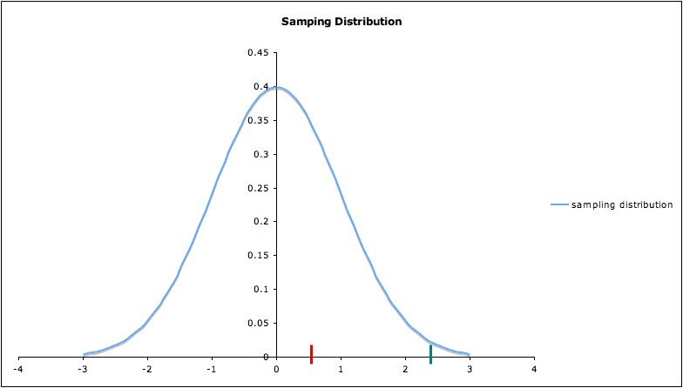

Case 1: If the t-statistic lies on the horizontal axis at the small bar shown in red (around 0.5) in the picture, *nothing is unusual*; our data are consistent with the null hypothesis.

Case 2: If the t-statistic lies on the horizontal axis at the small bar shown in green (around 2.5), then the data would be fairly *unusual* -- assuming the null hypothesis is true.

So ***a t-statistic of about 2.5 would cast some reasonable doubt on the null hypothesis*** but a t-statistic of about 0.5 would not cast reasonable doubt on the null hypothesis.

A t-statistic even further to the right would cast even more doubt on the null hypothesis.

*Note*: A little algebra will show that if t =  is unusually large, then so is , and vice-versa

***p-Values****The rough idea*: The p-value is a measure of evidence against the null hypothesis. (“What we want”)

*Recall from yesterday*:

* Choice of measure is often difficult; it may involve compromises.
* Carefully read the definitions of measures.
  + They may not be what you might think
  + This applies to the p-value

Misunderstandings of p-values are common!

*The idea a little less rough* (The rough idea of “What we get”):

The *p-value* is a quantitative measure of how unusual a particular sample would be *if* the null hypothesis were true (with lower p-values indicating a more unusual sample).

*The general (more precise) definition*: (“What we get”)

*p-value* = the probability of obtaining a test statistic *at least as extreme* *as* the one from the data at hand, *assuming* the model assumptions *and* the null hypothesis are all true.

So we are measuring how unusual the sample is by how extreme the test statistic is – in other words, *the p-value is used as a measure of unusualness of the sample – that is, unusualness assuming the model assumptions and the null hypothesis are true.*

Elaboration: The interpretation of "*at least as extreme as*" depends on the *alternative* hypothesis.

* For the one-sided alternative hypothesis *µ> µ0*(as in our example), "at least as extreme as" means "at least as great as".
  + Recalling that the probability of a random variable lying in a certain region is the area under the probability distribution curve over that region, we conclude that for this alternative hypothesis, *the p-value is the area under the sampling distribution curve to the right* *of the test statistic calculated from the data.*
  + With two different colors of pencils, we will shade in the p-values for both. Note that the p-value of the t-statistic of 2.5, at the green bar, is much less than that for the t-statistic of 0.5, at the red bar.

p

* Similarly, for the *other* one-sided alternative*, µ< µ0* , the *p-value is the area under the sampling distribution curve to the* *left* *of the calculated test statistic*.
  + Notice that the two data values whose t-scores we marked did NOT support this alternative hypothesis. *We wouldn’t even have to calculate a p-value to decide not to reject the null hypothesis.*
  + Nevertheless, we can calculate / estimate the p-values for the two data points we already had marked.
  + The p-value for the t-statistic at the green bar would be much greater than the t-statistic at the red bar, but both would be large as p-values go. Shade in the p-value here for the t-statistic of 2.5.



* For the two-sided alternative µ≠ µ0, shade in the p-value for the t-statistic of 2.5. Note that the *p-value would be the area under the curve to the right of the absolute value of the calculated t-statistic, plus the area under the curve to the left of the negative of the absolute value of the calculated t-statistic.*



* + Since the sampling distribution in the illustration is symmetric about zero, the two-sided p-value of, the t-statistic of 2.5, would be twice the area under the curve to the right of the green bar.  So you don’t have to calculate two areas, even though you have to shade in two areas.

Recall that in the sampling distribution, we’re only considering samples

* from the *same random variable*,
* that *fit the model assumptions* and
* *of the same size as the one we have*.

So if we spell everything out, the definition of p-value reads:

p-value = the probability of obtaining a test statistic *at least as extreme* as the one from the data at hand, *assuming*

1. *the model assumptions are all true, and*
2. *the null hypothesis is true, and*
3. *the outcome random variable is the same (including the same population), and*
4. *the sample size is the same.*

*Note 1*: This also assumes we are just considering one test statistic; there are in fact often choices of different test statistics for the same choices of null and alternate hypotheses; they won’t usually give the same p-value for the same data.

*Note 2*: ***The p-value is a random variable****.*

* The random process is __________________________
* The numerical value is calculated as

_____________________________________________

_____________________________________________

_____________________________________________

_____________________________________________

* In most cases, it can be proven mathematically that the distribution of the p-value (as a random variable) is the uniform distribution on the interval from 0 to 1.

*We can summarize the preceding discussion as:*

*If* we obtain an unusually small p-value, then (at least) one of the following must be true:

1. At least one of the model assumptions is not true (in which case the test may be inappropriate).
2. The null hypothesis is false.
3. The sample we’ve obtained happens to be one of the small percentage (of suitable samples from the same population and of the same size as ours) that result in an unusually small p-value.

Thus, if the p-value is small enough *and* all the model assumptions are met, then *rejecting the null hypothesis in favor of the alternate hypothesis* can be considered a rational decision, based on the evidence of the data used.

*However*: ….. on to the next slide ….

1. How small is "small enough" ***is a judgment call***.

2. "Rejecting the null hypothesis" does *not* mean the null hypothesis is false or that the alternate hypothesis is true. (Why?)

3. The alternate hypothesis is *not* the same as the scientific hypothesis being tested.

For example, the *scientific* hypothesis might be “This reading program increases reading comprehension,” but the statistical null and alternate hypotheses would be expressed in terms of a specific measure of reading comprehension.

* Different measures (AKA different outcome variables) would give different statistical tests (that is, different statistical hypotheses).
* These different tests of the same research hypothesis might lead to different conclusions about the effectiveness of the program.

***Comment on test statistics:***

Recall that the test statistic for the one-sample t-test is

t = 

Note that this has three components that affect how extreme the test statistic is:

1. The numerator $\overline{y}- μ_{0}$ measures how much the sample mean differs from the hypothesized population mean $μ_{0}$ (so sample means farther from the hypothesized mean give a larger test statistic, other things being equal)
2. The s in the denominator “scales” by sample standard deviation – so the test statistic is less extreme when there is a lot of variability in the measured quantity.
3. The $\sqrt{n}$ in the denominator of the denominator (which amounts to a $\sqrt{n}$ in the numerator) makes the test statistic more extreme when sample size is larger.

Typically, test statistics involve three analogous aspects:

1. A direct measure of a difference in question (with larger differences yielding more extreme test statistics)
2. A scaling by a measure of variability (with greater variability giving less extreme test statistic)
3. The sample size (with larger sample size giving more extreme test statistic)

**VI. MISINTERPRETATIONS AND MISUSES OF P-VALUES**

*Recall*:

p-value = the probability of obtaining a test statistic at least as extreme as the one from the data at hand, *assuming*:

1. the model assumptions for the inference procedure used are all true*, and*
2. the null hypothesis is true*, and*
3. the random variable is the same (including the same population)*, and*
4. the sample size is the same.

Note that this is a *conditional probability*: The probability that something happens, given that various other conditions hold. *One* **common mistake** *is to neglect some or all of the conditions*.

*Example A*: Researcher 1 conducts a clinical trial to test a drug for a certain medical condition on 30 patients all having that condition.

* The patients are randomly assigned to either the drug or a look-alike placebo (15 each).
* Neither the patients nor the medical personnel involved know which patient takes which drug.
* Treatment is exactly the same for both groups, except for whether the drug or placebo is used.
* The hypothesis test has null hypothesis "proportion improving on the drug is the same as proportion improving on the placebo" and alternate hypothesis "proportion improving on the drug is greater than proportion improving on the placebo."
* The resulting p-value is p = 0.15.

(*Continued on next page*)

Researcher 2 does another clinical trial on the *same drug*, with the *same placebo*, and *everything else the same* *except* that 200 patients are randomized to the treatments, with 100 in each group. The same hypothesis test is conducted with the new data, and the resulting p-value is p = 0.03.

Are these results contradictory?

No -- *since the sample sizes are different, the p-values are not comparable, even though everything else is the same.*

Indeed, *a larger sample size typically results in a smaller p-value*.

The idea of why this is true is illustrated by the case of the z-test, since large n gives a smaller standard deviation of the sampling distribution, hence a narrower sampling distribution.

Comparing p-values for samples of different size is a **common mistake**.

*Example B*: Researcher 2 from Example A does everything as described above, but for convenience, his patients are all from the student health center of the prestigious university where he works.

* He *cannot* claim that his result applies to patients other than those of the age and socio-economic background, etc. of the ones he used in the study, because his sample was taken from a smaller *population*.

*Example C*: Researcher 2 proceeds as in Example A, with a sample carefully selected from the population to which he wishes to apply his results, *but he is testing for equality of the means* of an outcome variable for the two groups.

* The hypothesis test he uses requires that the variance of the outcome variable for each group compared is the same.
* He doesn’t check this, and in fact the variance for the treatment group is twenty times as large as the variance for the placebo group.
* He’s *not* justified in rejecting the null hypothesis of equal means, no matter how small his p-value (unless by some miracle the statistical test used is robust to such large departures from the model assumption of equality of variances.)

(However there might be another test that is applicable when different groups have different variances.)  
  
Ignoring model assumptions is a **common mistake** in using hypothesis tests.

*Another* **common** **misunderstanding** *of p-values is the belief that the p-value is "the probability that the null hypothesis is true"*.

* This is essentially a case of confusing a conditional probability with the reverse conditional probability: In the definition of p-value, “the null hypothesis is true” is the condition, not the event that you’re considering the probability of.
* The basic assumption of frequentist hypothesis testing is that the null hypothesis is either true (in which case the probability that it is true is 1) or false (in which case the probability that it is true is 0). So unless p = 0 or 1, the p-value couldn’t possibly be the probability that the null hypothesis is true.

*Note*: In the *Bayesian* perspective, it makes sense to consider "the probability that the null hypothesis is true" as having values other than 0 or 1.

* In that perspective, we consider "states of nature;" in different states of nature, the null hypothesis may have different probabilities of being true.
* The goal is then to determine the probability that the null hypothesis is true, given the data: P(H0­ true | data)
* This is essentially the *reverse conditional probability* from the one considered in frequentist inference (the probability of the data given that the null hypothesis is true – P( data | H0­ true).

*Still another* **common misunderstanding***: “The p-value tells you whether or not the result was due to chance.”*

No, it just gives you a measure of *how consistent* the result is with being due to chance.

***p-value quiz:***

*You’ve done a two-sided t-test for a mean. The null hypothesis is H0: μ = 3; the alternate hypothesis is Ha: μ ≠ 3. You’ve obtained the p-value p = .06. Classify each statement below as:*

* *Doesn’t get it.*
* *Gets it partly, but misses some details*
* *Gets it!*

1. The probability that μ = 3 is 0.06.
2. The probability that μ ≠ 3 is 0.06.
3. The probability of getting the t-statistic you got from the data (assuming we’re considering just simple random samples of the same size and assuming *H0* and all model assumptions are true) is 0.06.
4. The probability of getting a t-statistic at least as large as the one we got from the data is 0.06, assuming we’re considering just simple random samples of the same size and assuming *H0* and all model assumptions are true.

(*Continued next page)*

5. The probability of getting a t-statistic with absolute value at least as large as the one we got from the data is 0.06, assuming we’re considering just simple random samples of the same size and assuming *H0* and all model assumptions are true.

6. If *H0* is true, then the probability of getting a value of t (from a simple random sample taken from the population in question) with absolute value at least as large as the one we obtained is .06.

7. If *H0* is true, then the probability of getting a value of t (from a simple random sample of the same size as the one we used, and taken from the population in question) with absolute value at least as large as the one we obtained is .06

8. If *H0* and all the model assumptions are true, then the probability of getting a value of t (from a simple random sample of the same size as the one we used, and taken from the population in question) with absolute value at least as large as the one we obtained is .06

*More misuses (abuses?) of p-values on Days 3 and 4*.

## VII: TYPE I ERROR AND SIGNIFICANCE LEVEL

***Type I Error:***

*Recall:*Rejecting the null hypothesis doesn’t necessarily mean the null hypothesis is false – because of inherent uncertainty in statistical inference, we might falsely reject the null hypothesis. This is called a *Type I error:*

***Type I Error:*** Rejecting the *null* hypothesis when it is in fact true.

***Significance level:***

Before doing a hypothesis test, many people decide on a maximum p-value for which they will reject the null hypothesis.

This should be done by balancing the consequences of the two different types of error and the costs of making each type of error.

This value is often denoted α (alpha) and is also called the ***significance level***.

When a hypothesis test results in a p-value less than the significance level, the result of the hypothesis test is called***statistically significant***, or ***significant at the* α *level****.*

*Confusing statistical significance and practical significance is a* **common mistake**.

*Example*: A large clinical trial is carried out to compare a new medical treatment with a standard one. The statistical analysis shows a statistically significant difference in lifespan when using the new treatment compared to the old one.

* However, the increase in lifespan is at most three days, with average increase less than 24 hours, and with poor quality of life during the period of extended life.
* Most people would not consider the improvement *practically significant*.

***Note:*** To lessen the possibility of confusing statistical and practical significance, various people have over the years proposed saying “statistically discernable” rather than “statistically significant,” but that is not widely practiced.

* I think that makes a lot of sense, and suggest that when you hear or read “statistically significant,” you think “statistically discernable,” to help prevent yourself from over-interpreting statistical significance.

***Caution***: The larger the sample size, the more likely a hypothesis test will detect a small difference. Thus *it’s especially important to consider practical significance when sample size is large.*

***Connection between Type I error and significance level:***

A significance level α corresponds to a certain value of the test statistic, say tα, with area under the curve to the right of tα equal to α.

tα is represented by the orange line in the picture of a sampling distribution below (the picture illustrates a hypothesis test with alternate hypothesis "µ > 0"),

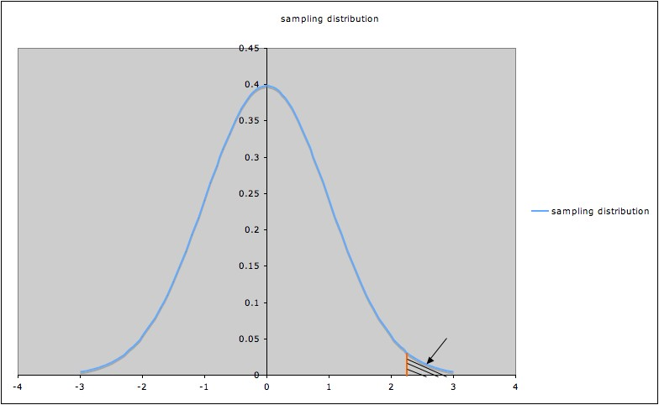

* Since the shaded area indicated by the arrow is the p-value corresponding to tα, that p-value (shaded area) is α.
* To have p-value less than α, a t-value for this test must be to the right of tα.
* So the probability of rejecting the null hypothesis when it’s true is the probability that t > tα , which we have seen is α.
* In other words, *the probability of Type I error is α*.
* Rephrasing using the definition of Type I error:

*The significance level α is the probability of making the wrong decision when the null hypothesis is true*.

*Note*:

* α is also called the *bound on Type I error*.
* Choosing a significance level α is sometimes called *setting a bound on Type I error*.

**Common mistake:** Claiming that an alternate hypothesis has been “proved” because it has been rejected in a hypothesis test.

* This is one instance of the mistake of “expecting too much certainty” discussed Monday.
* There’s *always* a possibility of a Type I error; the sample in the study might have been one of the small percentage of samples giving an unusually extreme test statistic.
  + **This is one important reason why *replicating studies* (i.e., repeating the study with another sample) is important.** 
    - The more (carefully done) studies that give the same result, the stronger the overall evidence.
    - Attention to replicating studies is growing, but still inadequate. (More on this tomorrow.)
* There’s also the possibility that the sample is biased or the method of analysis was inappropriate; either of these could also produce a misleading result.