Student: How to Access Your Stewart eBook
Watch this video to see steps on how to register: https://www.cengage.com/student-training/mindtap/canvas/ia-no
Or Follow steps below:
Access your Canvas Course
Click Modules (if Modules are not visible, please inform your instructor)
You may purchase eBook access through the link in Canvas or from the UT COOP.
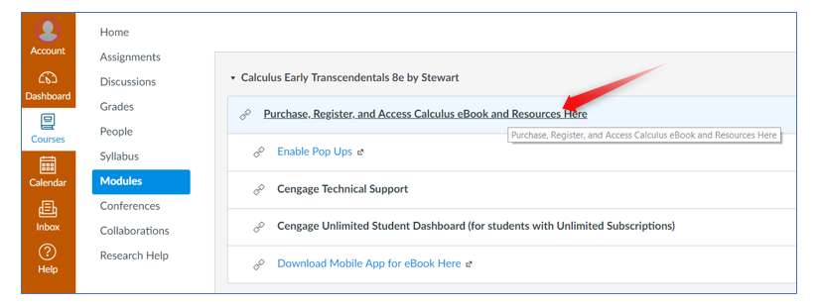
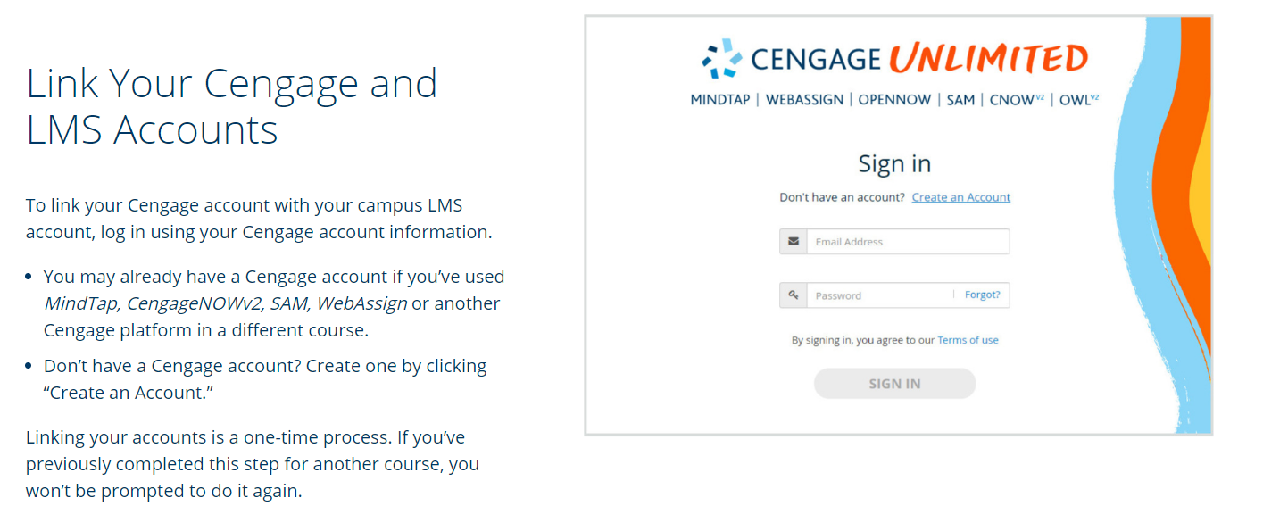
YOU WILL BE GIVEN THE OPTIONS BELOW AFTER USING THE FREE 14 day “GRACE PERIOD”
- Access for one semester for $30
- You have the option to purchase access to your materials through Cengage Unlimited—a digital subscription service designed to save you a lot of money. With Cengage Unlimited you can access ALL Cengage materials you are using in ANY courses AND a library of over 22,000 ebooks, study guides and reference materials.
Cengage Unlimited costs $119.99 for one term (four months), $179.99 for a multi-term (12 month) subscription or $239.99 for a multi-term (24-month) subscription.
As a bonus, when your subscription ends, you can choose up to six ebooks to retain in your virtual locker for an additional 12 months.
You will see a screen similar to the one below, PLEASE USE the “temporary access” to give yourself time to make the best purchasing decision, from the screen below choose “Access My Course” to access materials through this 14 day grace period.
*****If students purchase ACCESS to MindTap from the CO-OP, the student will instantly get an email from REDSHELF.
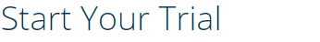
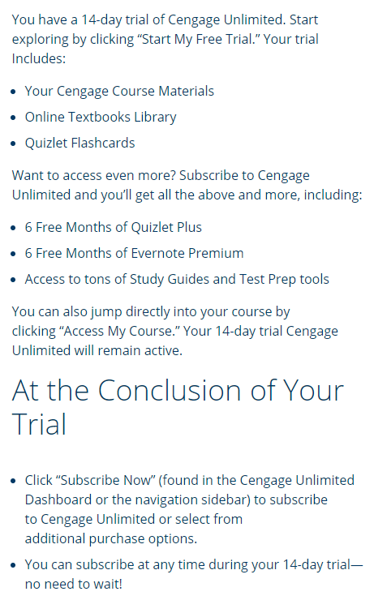

To access your text after registration, go back to Canvas and click on the same link, then on the box at the top of the screen, this time your book will open.

